BUSINESS REQUIREMENT DOCUMENT

<<Communication Journey:Aspirant Call with Career Coach>>

<<Dhawal Sah>>

<<Aravind Ravi Sankar>>

**VERSION: 1.0**

DATE <<2022-05-24 >>

**TABLE OF CONTENTS**

**1.1 Problem Statement/ Requirement Background** **3**

**1.2 Current Solution/Process (if any)** **3**

**1.3 Related Documents** **3**

**1.4 Solution Scope** **3**

**1.5 Constraints** **3**

**1.6 Business Goals and Objectives** **3**

**1.7 Priority** **3**

**1.8 Target User/ User Community** **3**

**1.9 Impact Analysis** **4**

**1.10 Additional Information** **4**

**1.11 Stakeholder consultation** **4**

**1.12 Approvers** **4**

### 

### 1.1 Problem Statement/ Requirement Background

What are the current problem statements faced by the Business owner?

Currently no notifications are being sent to Career Coaches regarding their calls query status. Also no reminder mails are sent if a Career Coach fails to resolve the call request.

Provide a brief introduction to the project. This includes describing the business context of the project and the users.

Career Coach Calls is a feature present in both app and CRM. Aspirants can request a Career Coach Call through the app and the Career Coaches have to call back the aspirant to resolve his/her queries. It is important to notify the Career Coaches on the pending requests of aspirants and also send them reminder mails if they still have not resolved the issues.

### 1.2 Current Solution/Process (if any)

Describe the current environment as it relates to the solution scope for this document. Does the client have an existing solution? What is it? What are some of its key challenges? What is being done manually?

Currently Career Calls is a feature used by aspirants to request calls from a Career Coach. Also Career coaches have to resolve their queries through the Coaches Call tab on CRM. Some of its features are:

1. Ability to Place Calls to an aspirant
2. Ability to Resolve Queries through Resolve Button
3. All requests visible on Call Requests tab
4. Displays the Call Date and Call time at which request was placed
5. All the Calls which have been made, get shifted to Recent Calls Tab

Other than this, a Career Coach can also place calls through the Call button present in *All Candidates* view across the respective candidate

Some of the key challenges include:

1. Career Coaches getting no notification after resolving a query of an aspirant either through Resolve Button or through Call
2. Career Coaches get no reminder if they have not received a query after a specific time.
3. No notification after Career Coach places a call without any query request

If the current solution has financial impacts, provide a high-level description.

### 1.3 Related Documents

Reference any business deliverables/documents associated with this requirements document.

### 

### 1.4 Solution Scope

Define the scope of the solution that this document describes. Indicate any components no longer in scope (e.g., scope changes from that described in the Preliminary Scope document).

Business Needs are of an automated Communication Journey for the placement calls feature having the following components:

1. automated mails to Career Coach after resolving an aspirant’s query through Call
2. automated mails to Career Coach after resolving an aspirant’s query through Resolve Button
3. automated mails to Career Coach if he/she has not resolved the query even after 2 of the total 3 hours
4. automated mails to Career Coach if he/she has not resolved the query even after 3 hours
5. automated mails to career Coach if he/she has made a call to an aspirant through *All Candidates* feature

Detailed Breakdown of these priorities: [Aspirant Call with Career Coach: Features and Priority List](https://docs.google.com/spreadsheets/d/1VFuk77oVYwN8tk1eFnz7K2RY3EUokh0Yd2ta0UgQ9cw/edit#gid=0)

### 1.5 Constraints

What are the business goals and objectives we are trying to achieve with this project

### 1.6 Business Goals and Objectives

What are the business goals and objectives we are trying to achieve with this project

Implementing Communication Journey to the Career Coach calls would make the whole process more efficient and time saving. Career Coaches would be reminded of their pending Call Requests and also they would be kept updated of all the Calls they are making to the aspirants. Since the whole communication journey is now being automated, there is a less chance of Career Coaches missing any calls/ taking a long time to call any aspirant. Also Career Coaches have a track of every call they have made in their mails thus making it easy for them to track the progress of any aspirant.

### 1.7 Priority

Use the following three categories to prioritize requirements (do not introduce and mix other prioritization methods such as the MoSCoW method):

* **High** to indicate a solution element that is critical to the client’s business function and operation;
* **Medium** to indicate a non-critical solution element that provides significant benefit to the client; and
* **Low** to indicate a non-critical solution element that provides a helpful or convenient feature that is beneficial to the client.

Detailed Breakdown of these priorities: [Aspirant Call with Career Coach: Features and Priority List](https://docs.google.com/spreadsheets/d/1VFuk77oVYwN8tk1eFnz7K2RY3EUokh0Yd2ta0UgQ9cw/edit#gid=0)

### 1.8 Target User/ User Community

If applicable, identify all possible user groups for the solution.

For each user group, estimate the number of users and reference the functional areas each will need access to.

All the Career Coaches

All the aspirants requesting call to a Career Coach through CRM

### 1.9 Impact Analysis

How is this product/feature

### 1.10 Additional Information

Include any information related to the requirement (e.g., hyperlinks to related online content). Where appropriate:

* Reference the associated business process model within the *Business Process Definition* document; and
* Identify the owner (e.g., source) of the requirement.

Communication Journey should include the following:

* Email Content - [Link](https://docs.google.com/spreadsheets/d/1VFuk77oVYwN8tk1eFnz7K2RY3EUokh0Yd2ta0UgQ9cw/edit#gid=0) (Doc links provided in the sheet)

**Additional Features**

There are some additional features which need to be added for the smooth functioning of communication Journey. Also these features are necessary for better tracking of activities of placement coordinators with the aspirants:

1. Instantly after the career coach call is disconnected, the Resolve pop - up should appear and there should be no cancel option, it is necessary for a career coach to add the content for Resolve pop-up. This because, the content of Resolve pop-up is sent to the aspirant in the communication journey
2. Also Calls which are made without a query request need to have a Resolve Query Pop-up.
3. Creation of new Group IDs for Career Coach where all the mails would be sent.
4. All Career Coach emails should be sent and received through a Common Email ID to ensure everyone is in the loop including the CC Manager.

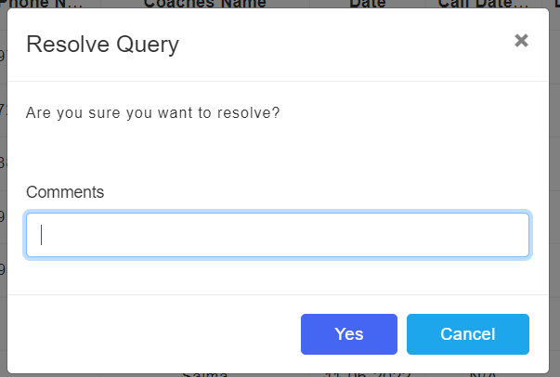

### 1.11 Stakeholder consultation

Identify the stakeholders for the solution and for the project, what their role(s) are, and whether they were consulted.

| **Stakeholder Name** | **Role** | **Consulted** |
| --- | --- | --- |
| Siddarth Nautiyal | Conveyed all the CRM features and also assisted me in understanding the Communication Journey | Yes |
| Aravind Ravi Sankar | Reviewed all the Communication Journeys and all the use cases | Yes |

### 1.12 Approvers

The following individuals have approved the financial requirements on the date indicated.

| **Approver Name** | **Role** | **Approved** |
| --- | --- | --- |
|  |  | << Yes / No >> |
|  |  | << Yes / No >> |
|  |  | << Yes / No >> |